iPad Aps
Content | Title | LS |  | MS |  | HS |  | Free | Cost
Art  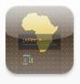 | iAfrica Minneapolis Inst of Arts |  |  | X |  | X |  | X
Art | PS Express –  Adobe photo edit |  |  | X |  | X |  | X
Art  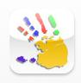 | Finger Sketch | X |  | X |  | X |  |  | Finger Pro  $2.99
Art | Doodle Buddy | X |  | X |  | X |  | X
Art | Art Puzzle HD Lite | X |  | X |  | X |  | X
Art  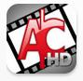 | Animation Creator HD | X |  | X |  | X |  | X | Free with Upgrade $1.99
Art  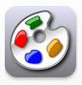 | ArtStudio | X |  | x |  | X |  |  | @2.99
Art  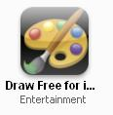 | Draw Free for iPad | X |  | X |  | X |  | X
Art  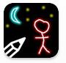 | Glow Draw | X |  | X |  | X |  | X
Art  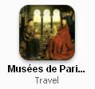 | Musees de Paris |  |  | X |  | X |  |  | $1.99
Art | Musee du Louvre (iPhone) |  |  | X |  | X |  | X
Art | Vizeum  (Global museum base) |  |  |  |  | X |  | X
Art | National Gallery, London |  |  | X |  | X |  | X
Art | MoMA |  |  |  |  | X |  | X
Art | Adobe Ideas (Sketch layers) |  |  | X |  | X |  |  | $5.99
Assistive Tech | Sign Language Alphabet Trainer | X |  | X |  | X |  |  | $4.99
Assistive Tech  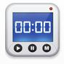 | Timer | X |  | X |  | X |  | X
Assistive Tech  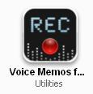 | Voice Memos for iPad | X |  | X |  | X |  | X
Assistive Tech  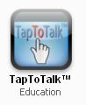 | Tap to Talk | X |  |  |  |  |  | X
Assistive Tech  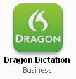 | Dragon Dictation | X |  | X |  | X |  | X
Collaboration | Edmodo (Individual library set up with file share) |  |  | X |  | X |  | X
Collaboration  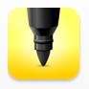 | iBrainstorm |  |  |  |  |  |  | X
Collaboration | Skype |  |  |  |  |  |  | X
Collaboration | WebEx for iPad  (meetings on your iPad) |  |  |  |  |  |  | X
Collaboration | Whiteboard lite  (Collaborative Drawings) | X |  | X |  | X |  | X
Collaboration  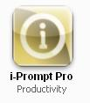 | iPrompt Pro | X |  | X |  | X |  | X
Current events  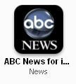 | ABC News for iPad |  |  | X |  | X |  | X
Current events | AP News |  |  | X |  | X |  | X
Current events  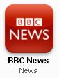 | BBC News |  |  | X |  | X |  | X
Current events  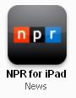 | NPR |  |  | X |  | X |  | X
Current events  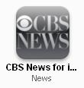 | CBS News |  |  | X |  | X |  | X
Current events | NY Times for iPad |  |  | X |  | X |  | X
Current events  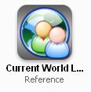 | World Leaders |  |  | X |  | X |  |  | .99
Current events | Campaigns and Elections magazine |  |  | X |  | X |  | X
Current events | NewsShare (Europe) |  |  | X |  | X |  | X
Current events | MSNBC Cartoons HD |  |  | X |  | X |  | X
Current events | CNN |  |  | X |  | X |  | X
Current events | Today (News) |  |  | X |  | X |  | X
Current events | EyeWitness Guardian (photo Journ) |  |  |  |  | X |  | X
Current events  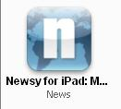 | Newsy  (News video aggregate) |  |  |  |  | X |  | X
Current events  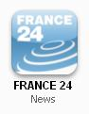 | France 24  (News from France in English or French) |  |  |  |  | X |  | X
Current Events  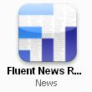 | Fluent News  (News aggregate) |  |  | X |  | X |  | X
Current Events | American Bar Association  Journal |  |  |  |  | X |  | X
ELA  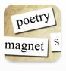 | Poetry Magnets | X | X |  | X |  | X
ELA  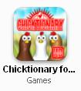 | Chicktionary | X |  |  |  |  | X
ELA  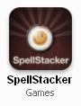 | Spell Stacker  (Word Game) |  |  |  |  |  |  |  | $2.99
ELA | Vocab Rootology  (5,000 combined flash cards and multiple choice questions (Greek & Latin)) |  | X |  | X |  |  |  | $2.99
ELA  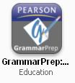 | Pearson Grammar Prep  (Several options from pronouns, commas, fragments, capitalization, etc.) |  |  |  | X |  |  |  | $3.99@
ELA  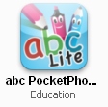 | ABC Phonetics Lite | X |  |  |  |  |  |  | Upgrade $2.99
ELA  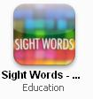 | Sight Words  (There are several Apps for sight words!) | X | X |  |  |  | X
ELA | EduBook Tales  (29 Public Domain Classic Novels) |  | X |  | X |  |  |  | $.99
ELA  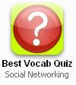 | Best Vocab Quiz |  | X |  | X |  | X
ELA  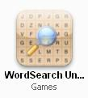 | Word Search  (Game) |  | X |  | X |  | X
ELA  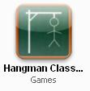 | Hangman Class | X | X |  | X |  | X
ELA  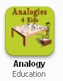 | Analogy  (Analogies for Kids) | X | X |  |  |  |  |  | $.99
Economics  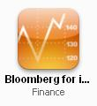 | Bloomberg |  |  |  | X |  | X
History/Social Studies  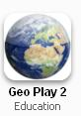 | Geo Play  (Game to test world geography knowledge) |  | X |  | X |  | X
History/Social Studies | iUSA  (Links to wiki articles on states, news, historical places, and presidents) |  | X |  | X |  | X
History/Social Studies | Today In History | X | X |  | X |  | X
History/Social Studies  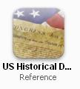 | US Docs | X | X |  | X |  | X
History/Social Studies  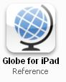 | Globe  (Tap on country to access information) | X | X |  | X |  | X
History/Social Studies | Pass the Past  (History, geography, civics, US, & World) |  | X |  | X |  | X
History/Social Studies  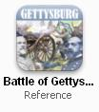 | Battle of Gettysburg |  | X |  | X |  |  |  | $.99
Math  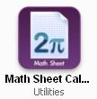 | Math Sheet Calculator |  | X |  | X |  | X
Math  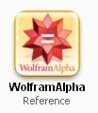 | WolframAlpha | X | X |  | X |  |  |  | $1.99
Math  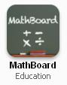 | MathBoard  (Addition app is free) | X | X |  | X |  |  |  | $4.99
Math  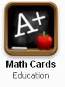 | Math Cards  Addition, subtraction, division, multiplication | X | X |  |  |  |  |  | $.99
Math  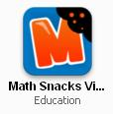 | Math Snacks Video | X | X |  |  |  | X
Math  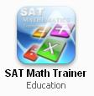 | SAT Math Trainer |  |  |  | X |  | X
Math  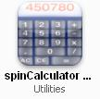 | spinCalculator  (voice, great for AT) | X | X |  | X |  | X
Math  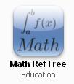 | Math Ref Free  (equations and formulas) |  | X |  | X |  | X
Math  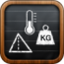 | Convert  (Converts metric, money, weights, etc.) | X | X |  | X |  | X
Math  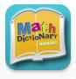 | Math Dictionary for Kids | X | X |  |  |  |  |  | $4.99
Math  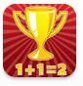 | Master the Math  (review of VA math curriculum 3-8th grades) | X | X |  |  |  | X
Math | Virtual Manipulatives  (Fractions, Decimal, Percentages) | X | X |  |  |  | X
Math  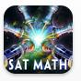 | Intellective: SAT Math |  |  |  | X |  | X
Math  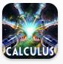 | Intellective: Calculus  (To prepare for advance placement and SAT exams) |  |  |  | X |  | X
Math  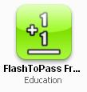 | FlashToPass  (Math Flash Cards) | X | X |  |  |  | X
Music  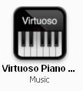 | Virtuoso Piano | X | X |  | X |  | X
Music  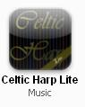 | Celtic Harp Lite | X | X |  | X |  | X |  | Upgrade $2.99
Music  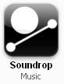 | Soundrop | X | X |  | X |  | X
Music  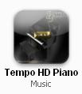 | Piano HD  (Tempo HD Piano) |  | X |  | X |  | X
Music  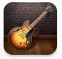 | Garage Band | X | X |  | X |  |  |  | $4.99
Music  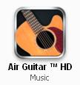 | Air Guitar HD | X | X |  | X |  | X
Reference  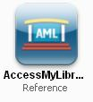 | Access My Library  (Access card catalogs) | X | X |  | X |  | X
Reference  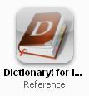 | Dictionary  (Word prediction & voice pronunciations) | X | X |  | X |  | X
Reference  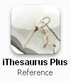 | (iThesaurus Plus  Definitions, examples, frequency of use) | X | X |  | X |  | X
Reference  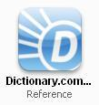 | Dictionary.com  (word of the day, voice pronunciation) | X | X |  | X |  | X
Reference  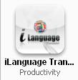 | iLanguage Translator | X | X |  | X |  | X
Reference | Howcast  (How to Videos - rated 9+ due to infrequent /mild mature/suggestive themes) |  |  |  | X |  | X
Reference | Wikihood  (Searches the area in which you are and returns information on what is around you) | X | X |  | X |  | X
Reference  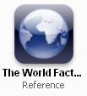 | World Fact Book | X | X |  | X |  |  |  | $.99
Reference | The Forbes List  (List of Forbes 400/Billionaires with biographies) |  | X |  | X |  | X
Reference  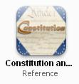 | Constitution | X | X |  | X |  | X
Science  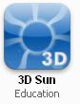 | 3D Sun |  | X |  | X |  | X
Science  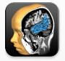 | Brain Tutor HD |  | X |  | X |  |  |  | $1.99
Science | LabTimer |  | X |  | X |  | X
Science  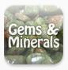 | Gems and Minerals | X | X |  | X |  |  |  | $.99
Science | Star Walk for iPad | X | X |  | X |  |  |  | $4.99
Science  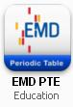 | EMD PTE  (Periodic Table) |  | X |  | X |  | X
Science  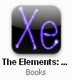 | The Elements: A Visual Exploration |  |  |  | X |  |  |  | $13.99
Science  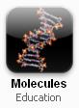 | Molecules |  | X |  | X |  | X
Science  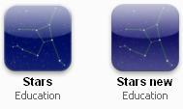 | Stars/Stars new | X | X |  | X |  | X
Science  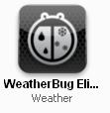 | WeatherBug | X | X |  | X |  | X
Science  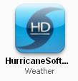 | Hurricane HD |  | X |  | X |  | X
Science | NASA | X | X |  | X |  | X
Science  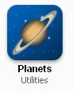 | Planets | X | X |  | X |  | X
Science | Virtual Bacterial ID LAb |  | X |  | X |  | X
Science/Medicine  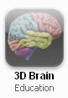 | 3D Brain |  | X |  | X |  | X
Science/Health | WebMD |  |  |  | X |  | X
Science  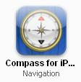 | Compass for iPad | X | X |  | X |  | X
Science  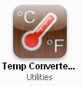 | Temperature Converter HD | X | X |  | X |  | X
Science  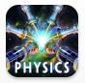 | Intellective: Physics  (To prepare for advance placement and SAT exams) |  |  |  | X |  | X
Science  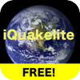 | iQuake Lite | X | X |  | X |  | X
Science  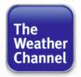 | TWC-iPad | X | X |  | X |  | X
Text Readers  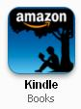 | Kindle | X | X |  | X |  | X
Text Readers | iBooks | X | X |  | X |  | X
Text/Audio Readers  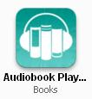 | Audiobook HD |  | X |  | X |  | X
Text Readers | Nook for iPads | X | X |  | X |  | X
Text Readers  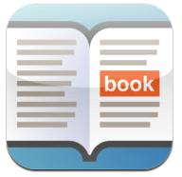 | Read2Go | X | X |  | X |  |  |  | $19.99
Text Readers | Barnes and Noble Nook Kids (Store link is deactivated) | X |  |  |  |  | X
Utilities/Productivity | Terra  (Web Browser with Tabs for iPad) | X | X |  | X |  | X
Utilities/Productivity | Apps Fire (apps stream for iPad)  Visual Apps store |  |  |  |  |  | X
Utilities/Productivity  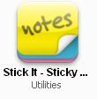 | Stick It  (Sticky Notes for the iPad) |  | X |  | X |  | X
Utilities/Productivity  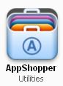 | App Shopper |  |  |  | X |  | X
Utilities/Productivity  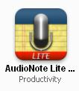 | AudioNote Lite | X | X |  | X
Utilities/Productivity  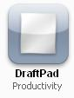 | DraftPad |  | X |  | X |  | X
Utilities/Productivity  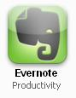 | Evernote  (Organizational tool) |  | X |  | X |  | X
Utilities/Productivity  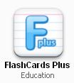 | FlashCards Plus | X | X |  | X
Utilities/Productivity  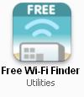 | Free Wi-Fi Finder |  |  |  |  |  | X
Just for Fun | Big Box Visual Effects Pro | X | X |  | X |  | X
Just for Fun | British Jargon |  |  |  | X |  | X
Just for Fun  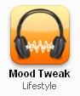 | Mood Tweak  (sounds) | X | X |  | X |  | X
Just for Fun  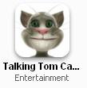 | Talking Tom | X | X |  | X |  | X
Just for Fun  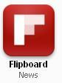 | Flipboard  (Social Media in one place: Facebook, Twitter, LinkedIn, Google Reader, etc.) |  |  |  | X |  | X
Just for Fun  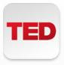 | TED  (Remarkable people, remarkable talks) |  |  |  |  |  | X
Just for Fun | TrendTopic  (See what is hot in Google searches, twitter ) |  | X |  | X |  | X
Just for Fun | Pandora Radio  (Set up radio channels by artists or genre) |  |  |  |  |  | X
Just for Fun | SnowCat |  |  |  |  |  | X
Just for Fun | Hulu Plus |  |  |  |  |  |  |  | $7.99 mo.
Just for Fun | Netflix  (Subscription for television also works on iPad) |  |  |  |  |  |  |  | Monthly subscription  Includes APP
Just for Fun | TW Cable TV  (cable fees for Warner Cable) |  |  |  |  |  |  |  | Monthly Subscription  Includes  App
Just for Fun | eBook Search  (Look for free eBooks) | X | X |  | X |  | X
Just for Fun | iTunes Movie Trailers |  |  |  | X |  | X
Just for Fun | IMDb |  | X |  | X |  | X
Just for Fun  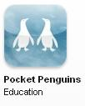 | Pocket Penguins  (Watch the penguins on web cam) | X | X |  | X |  | X
Just for Fun  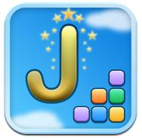 | Jumbline2 |  | X |  | X |  | X
Just for Fun  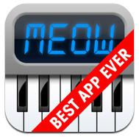 | Cat Piano | X | X |  | X |  |  |  | $.99
Just for Fun  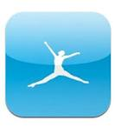 | MyFitnessPal  For iPhone/iPod |  | X |  | X |  | X

